3 класс
Kонтрольная работа
по теме: “ANIMALS”

Match:
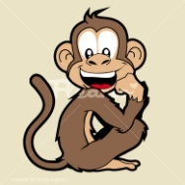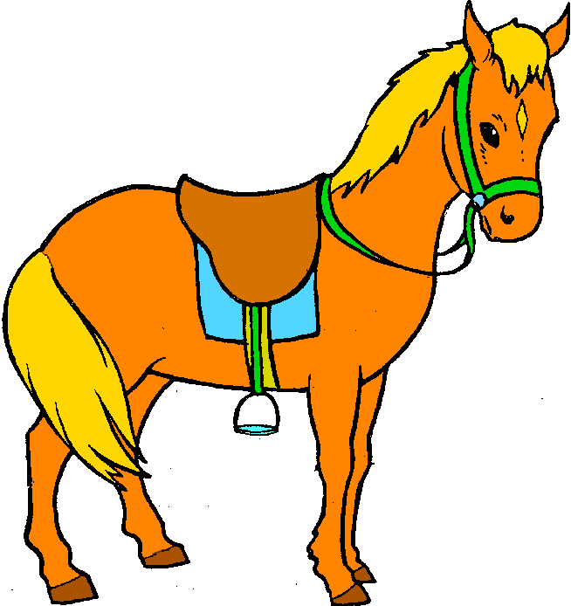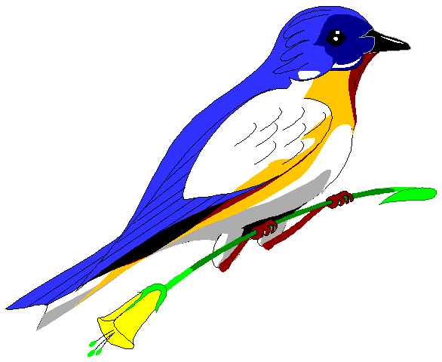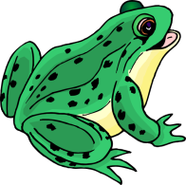
1.---------------- 2.--------------------- 3.-------------------- 4.--------------------
a) frog b) girl c) fish d) boy e) horse f) chimp g) clown h) bird

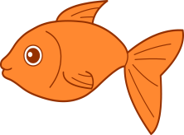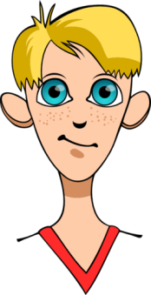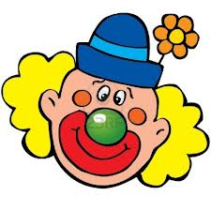
5) --------------- 6) ------------------ 7)-------------------- 8)---------------------
II. Guess: What can…?
climb sing jump swim
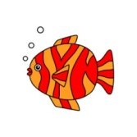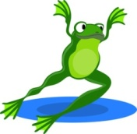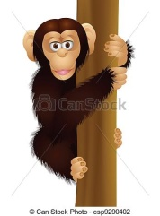

III. Complete:
- ---------------- can swing. 3. ------------------- can fly.
- ------------------- can dance. 4. ------------------- can run.
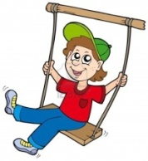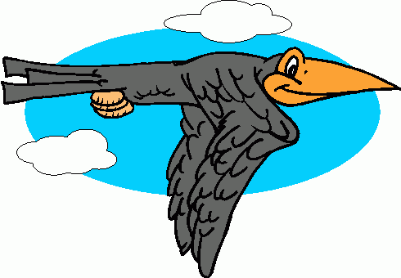
Meg Sam Bob Bird

IV. Read and choose.
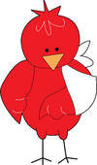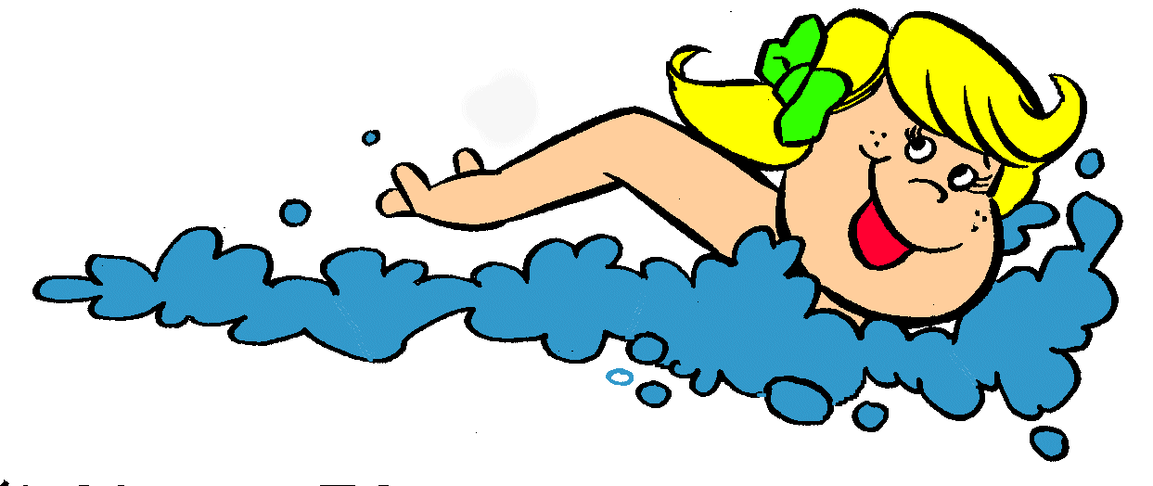
Can a bird fly? Can you run? Can you swim?
Yes, it can. Yes, I can. No, I can`t.
No, it can`t. No, I can`t. Yes, I can.
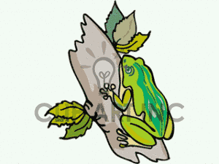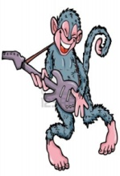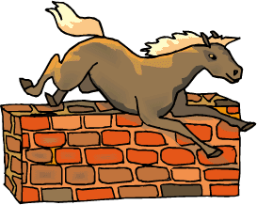
Can a frog climb? Can a chimp sing? Can a horse jump?
No, it can`t. Yes, it can. No, it can`t.
Yes, it can. No, it can`t. Yes, it can.

